**EXPERIMENT 5**

**Studies on analog circuits using op-amp**

|  |  |
| --- | --- |
| **Name:** | Keerti P. Charantimath |
| **Roll Number:** | 19MA20059 |

1. **Aim of the experiment:**
   * Explain and observe the properties of inverting and non inverting op-amps.
   * Explain gain of an op-amp circuit.
2. **Tools used:** 
   * Op-amp
   * Resistors(2-100kOhms)
   * DC power source(12Vx2, 1Vx1, 2Vx1, 3Vx1)
   * Connecting wires
   * Capacitors(1μF, 0.47μF, 47pF)
   * AC power source
3. **Background knowledge:**
   * Operational Amplifier commonly known as Op-Amp, is a linear electronic device having three terminals, two input terminals and one output terminal. OpAmp can perform multiple functions when attached to different feedback combinations. It can be used as voltage amplifier with output voltage of the Op-Amp equal to the difference between the two input voltages. In an ideal opamp, the open loop gain and input impedance is infinite (practically very high), Output impedance and offset voltage is zero (practically very low).
   * **Inverting Opamp:**



The open loop gain of the Om-Amp is very high which makes it very unstable, so to make it stable, a feedback is applied through a resistor(Rf) from its output to inverting input terminal(also known as negative feedback). This produces reduced gain (closed loop gain, Av). So the voltage at inverting terminal is now the sum of the actual input and feedback voltages, and to separate both an input resistor (Ri) is introduced in the circuit. The non inverting terminal is grounded, and the inverting terminal behaves like a virtual ground since the input impedance is very high. The output voltage and closed loop gain is given as:

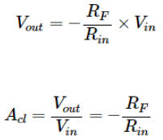

* + **Non-Inverting Amplifier:**



The input signal is fed to the non-inverting terminal of the opamp, resulting in a positive gain and output voltage in phase with input as compared to inverting Op-amp where the gain is negative and output voltage is out of phase with input. To stabilize the circuit, a negative feedback is applied through a resistor (Rf) and the inverting terminal is grounded. The inverting terminal has a resistor (R2) connected with it. It creates a virtual ground at the summing point, making the Rf and R2 a potential divider across the inverting terminal, hence determining the gain of the circuit. The output voltage and closed loop gain is given as follows:

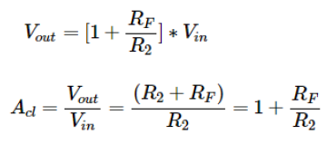

* + **The Integrator**

It is a circuit designed with OpAmp in such a way that it performs the Integration operation on the input signal. Its output is proportional to the amplitude and time duration of the input signal. The integrator circuit is same as an inverting amplifier but the feedback resistor is replaced by a capacitor which makes the circuit dependent on frequency of input. The charging and discharging of the capacitor depends on the time duration of the applied input. Initially when the voltage is applied to integrator circuit, the uncharged capacitor lets maximum current to flow through it and no current flows through the Opamp due to virtual ground. The capacitor starts to charge at the rate of RC (time constant) and its impedance increases with time. A potential difference is developed across the capacitor resulting in the charging current to decrease. This results in the ratio of capacitor's impedance and input resistance increasing, causing a linearly increasing ramp output voltage that continues to increase until the capacitor becomes fully charged.





* + **The Differentiator**

In the differentiator circuit, the input is connected to the inverting output of the Opamp through a capacitor. A negative feedback is provided to the inverting input terminal through a resistor (Rf), which is same as an integrator circuit with feedback capacitor and input resistor being replaced with each other. Here the circuit performs a differentiation operation on the input signal, and the output is the first derivative of the input signal, 180 degrees out of phase and amplified with a factor Rf*C. The capacitor on the input allows only the AC component and restricts the DC. At low frequencies, the reactance of the capacitor is very high causing a low gain and high frequency and vice versa. At high frequency the circuit becomes unstable.





* + **Summing Amplifier:**

The summing Amplifier is one variation of inverting amplifiers. This simple inverting amplifier can easily be modified to summing amplifiers, if we connect several input terminals in parallel to the existing input terminals. Here, in the circuit, the non-inverting terminal of the op amp is grounded, hence potential at that terminal is zero. As the op amp is considered an ideal op amp, the potential of the inverting terminal is also zero. The output Voltage can be expressed in terms of the input as

If more inputs are used, they each add an additional component to the output. Each input adds a voltage to the output multiplied by its separated constant gain multiplier.

* + **Superposition:**

We have till now considered only the circuits that accept signals at only one of the two output input terminals of the op- amps. An op-amp circuit can provide simultaneous inputs at the inverting and non-inverting terminals. Using the superposition theorem which in this case implies that if VOUT is the response due to V1 acting alone i.e. with V2 being grounded. Then response due to both inputs is added.

**Inverting Amplifier**

**DC Gain**

**Circuit Diagram:**

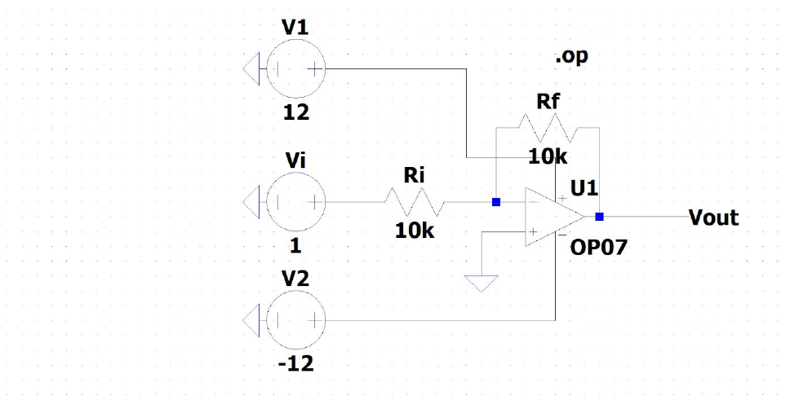

Theoretical Gain = -(Ri/Rf)

Observation Table for Vi = 1V DC and Ri = 10kΩ

|  |  |  |  |
| --- | --- | --- | --- |
| **Serial Number** | **Rf in kΩ** | **Output Voltage in V** | **Gain** |
| 1 | 10 | -0.999997 | -1 |
| 2 | 27 | -2.69999 | -2.7 |
| 3 | 47 | -4.69996 | -.4.7 |
| 4 | 100 | -9.99985 | -10 |

* + Virtual Ground: Voltage at virtual ground terminal obtained from DC analysis is 1.34029e-005 which is approximately 0(at ground)
  + Current in Ri = 9.99987e-005

Ri value calculated = Vin/Iin = 1/9.99987e-005 = 10,000.13Ω which is approximately 10kΩ

* + Saturation Voltage = -11.0678 (<12V biasing)

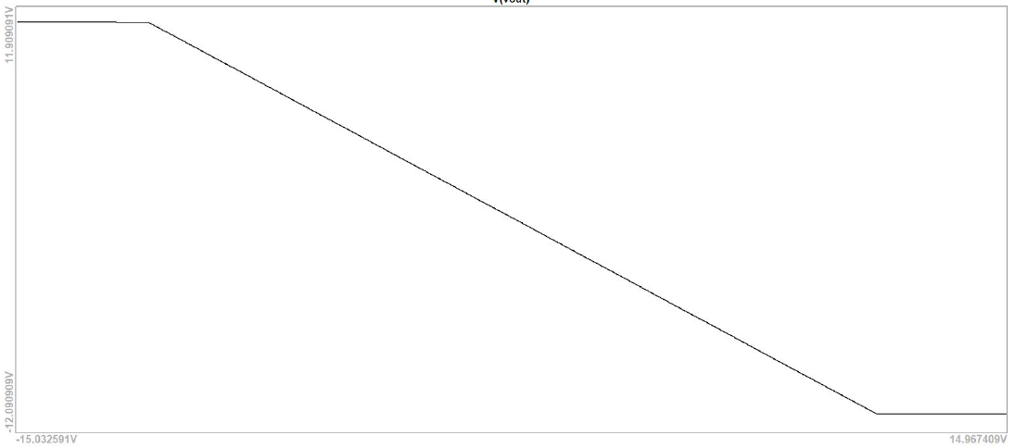

Plot for DC sweep analysis, confirming saturation voltage = 11.06V

**Non-Inverting Amplifier**

**Circuit Diagram:**

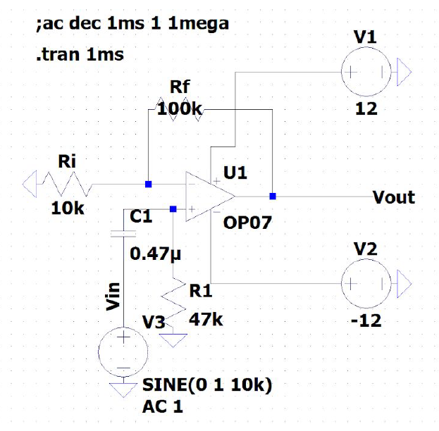

Theoretical Gain = 1 + (Ri/Rf)

**Waveforms for Rf = 10kΩ**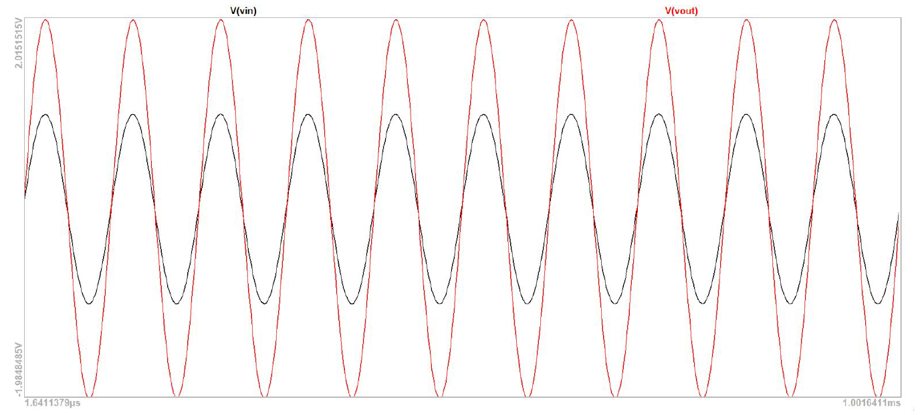

Peak output voltage = 2V

Gain = 2

**Waveforms for Rf = 27kΩ**

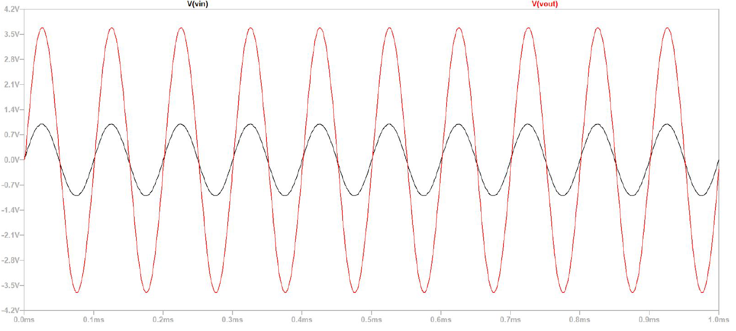

Peak Output Voltage = 3.7V

Gain = 3.7

**Waveforms for Rf = 47kΩ**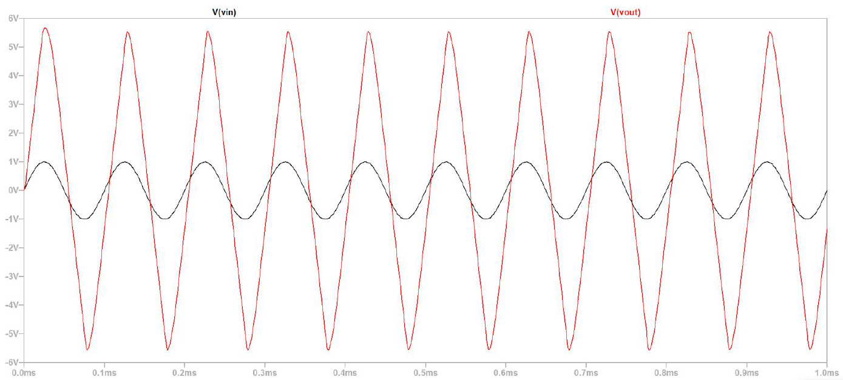

Peak output voltage = 5.7V

Gain =5.7

**Waveforms for Rf = 100kΩ**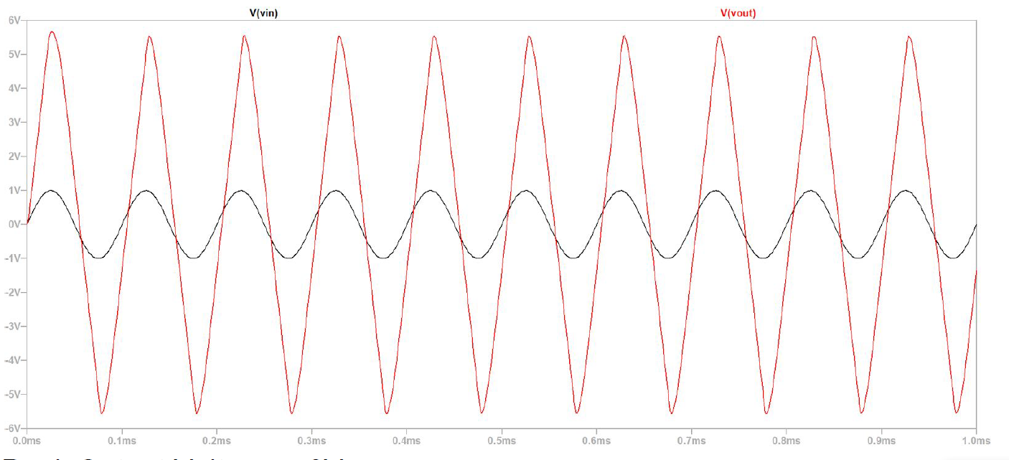

Peak Output Voltage = 6V

Gain = 6

**Frequency Response**

**Circuit Diagram:**

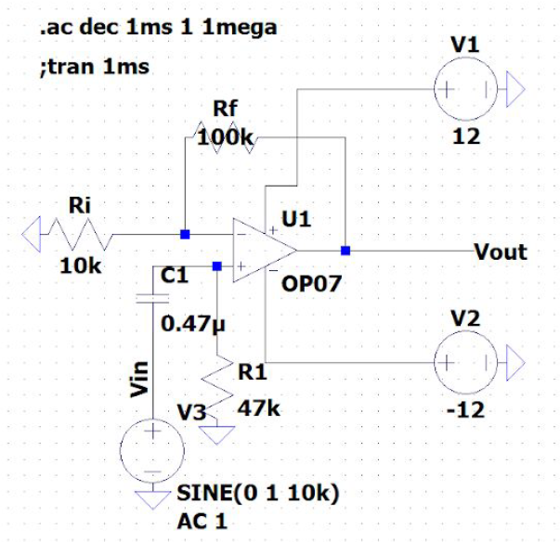

* + AC analysis is done on a range of frequencies from 1 - 1MHz.
  + Simulation command is given in the top left of the circuit diagram.
  + Reactance of the capacitor = 1/2𝞹fC = 33.8Ω
  + Upper and lower cutoff frequencies are 3dB lower than maximum gain.

**Rf = 27kΩ**

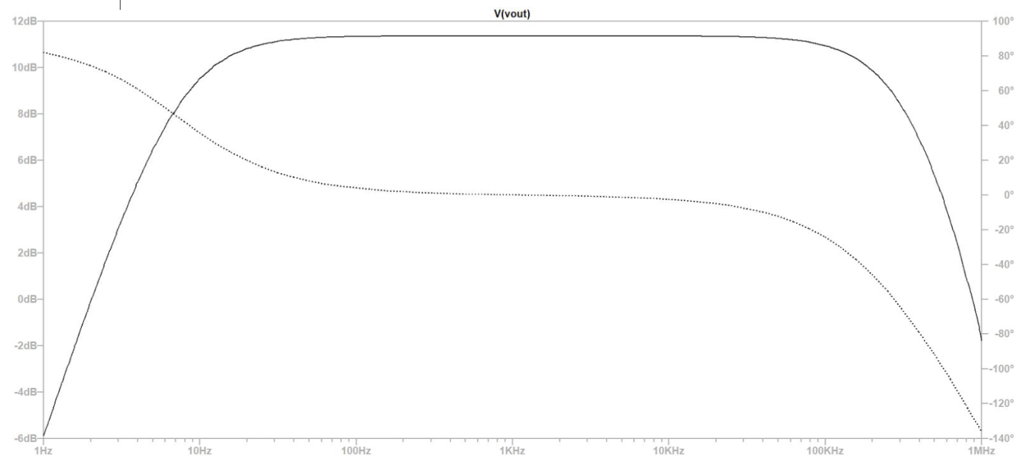

**Rf = 47kΩ**

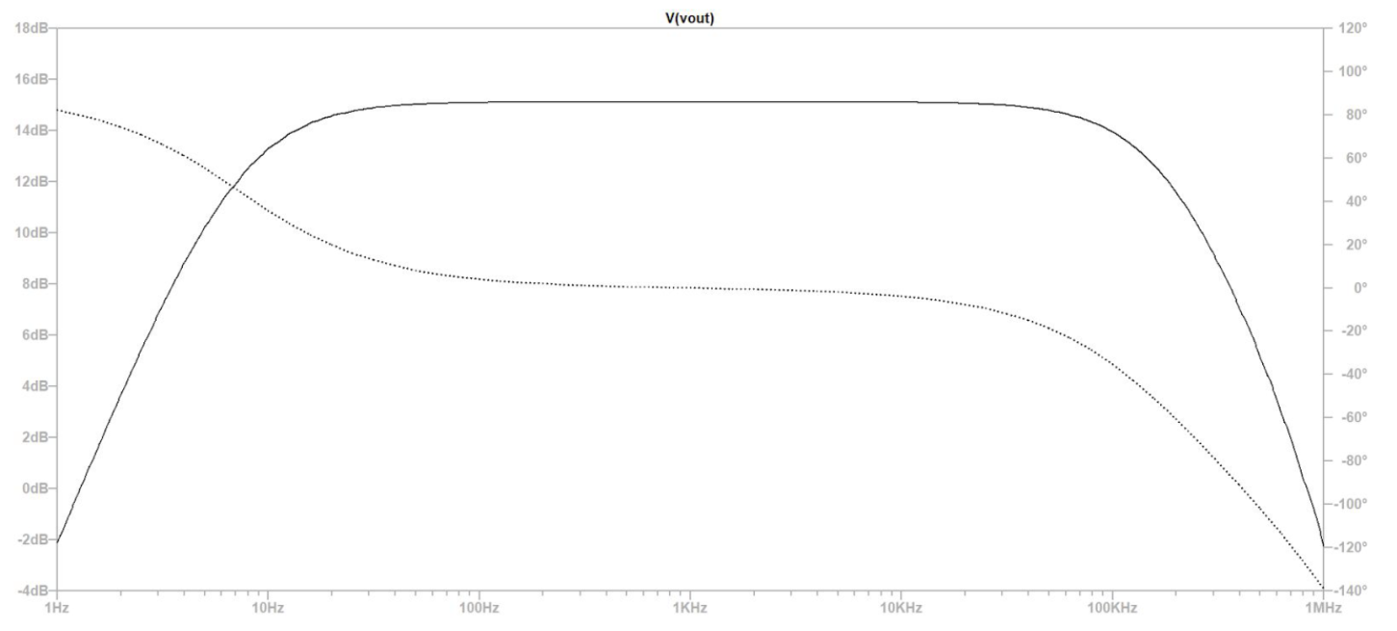

**Rf = 100kΩ**

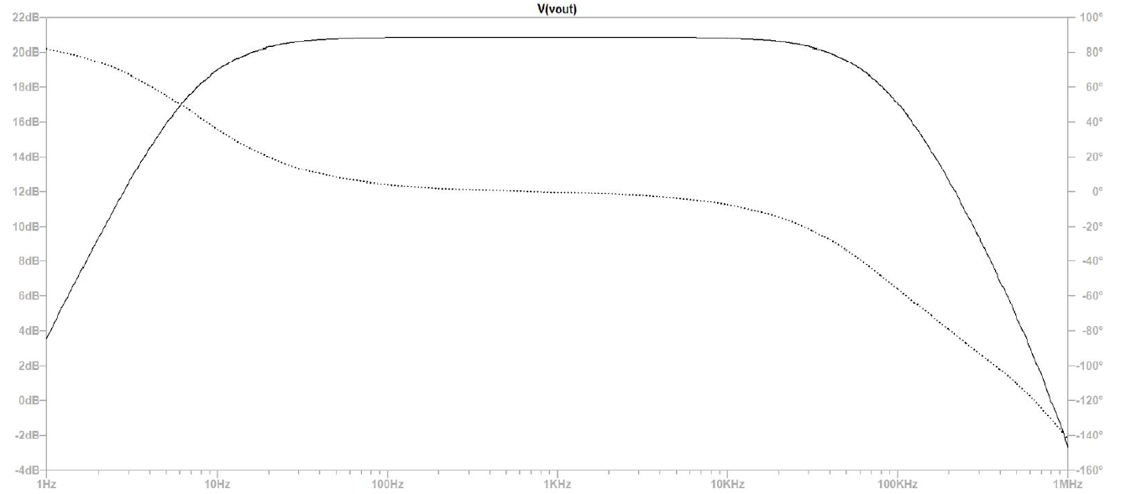

|  |  |  |  |  |
| --- | --- | --- | --- | --- |
| **S.No.** | **Rf(kΩ)** | **Gain** | **Bandwidth(kHz)** | **Gain x Bandwidth(kHz)** |
| 1 | 10 | 2 | 686.60 | 1373.230 |
| 2 | 27 | 3.7 | 306.03 | 11226.27 |
| 3 | 47 | 5.7 | 178.57 | 983.925 |
| 4 | 100 | 6 | 84.50 | 5651.191 |

For Rf = 27kOhms

Av = 3.66

𝛽 = Ri/(Ri + Rf) = 0.27027

Av = Ao(1+ 𝛽Ao) => 338.519

**Voltage Follower**

**Circuit Diagram:**

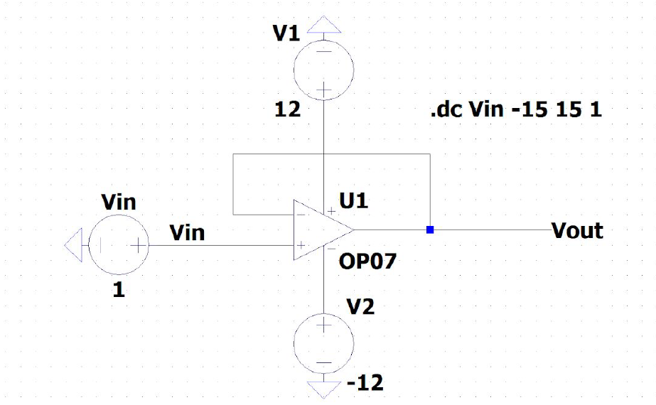

* + DC analysis for Vin = 1 shows Vout to be 0.999999V
  + From DC analysis it is observed Vin = Vout for a range of Vin.
  + Vin = Vout holds true only for Vin values ranging from -11.1 V to 11.1V
  + As observed from the DC sweep analysis

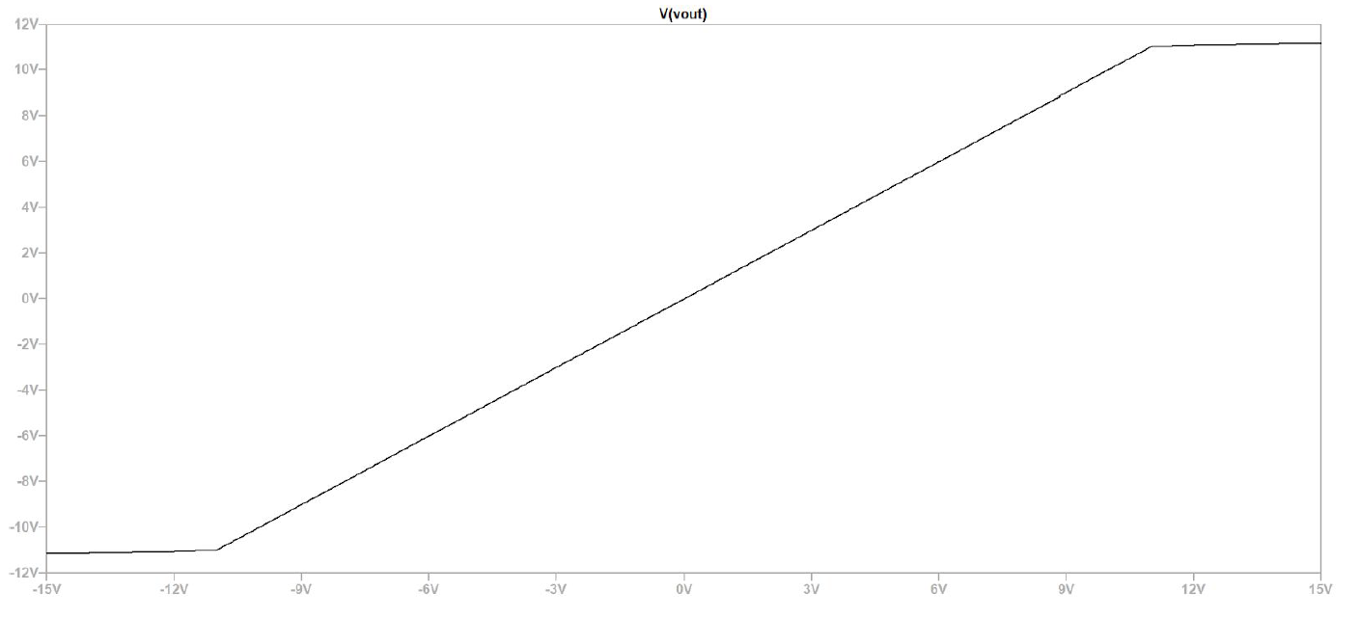

**Adder**

**Circuit Diagram**

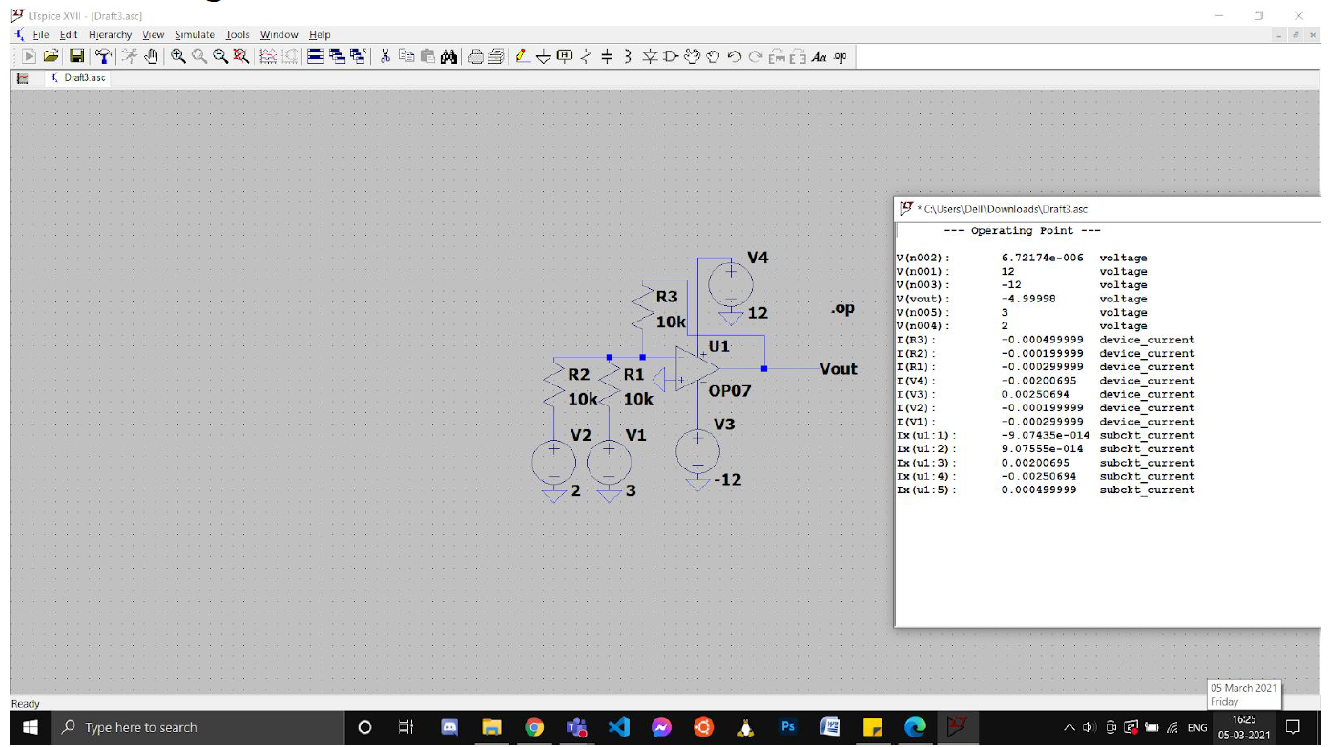



DC analysis shows voltage at Vout to be -4.99998V. Which is approximately the inverted sum of V1 and V4

**Summing Amplifier**

**Circuit Diagram:**

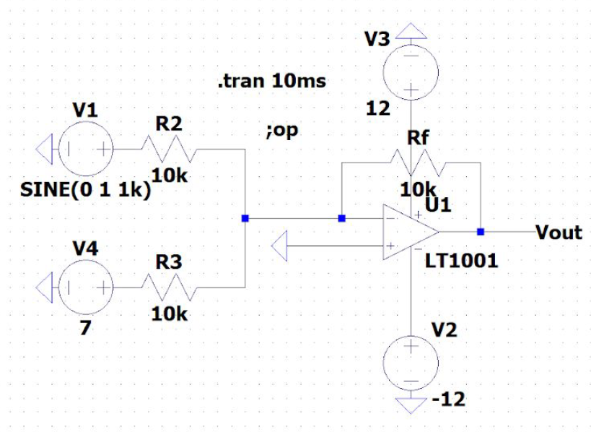

The same circuit as that of the ‘adder’ can also be used to offset an AC

signal by providing the AC signal at V1 and a DC signal at V4 in the given

circuit.

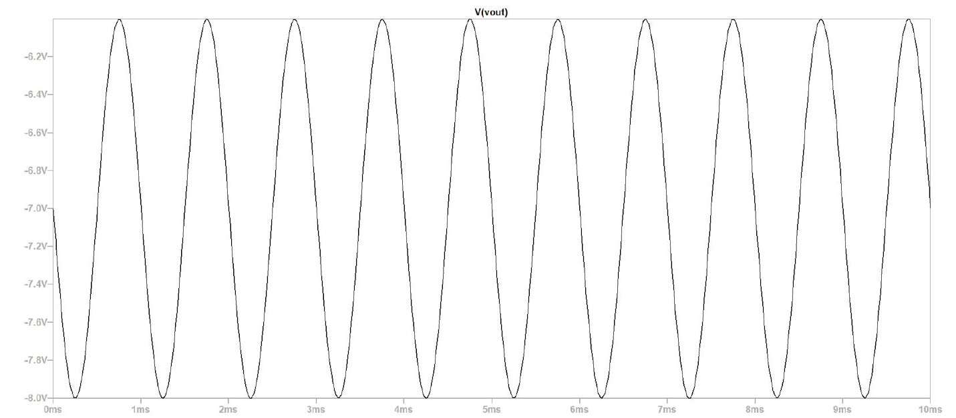

This is the variation of Vout with time for V1 = 1V 1kHz AC signal

V4 = 7V DC. Clearly output signal varies from -8V to -6V

**Superposition**

**Circuit Diagram:**

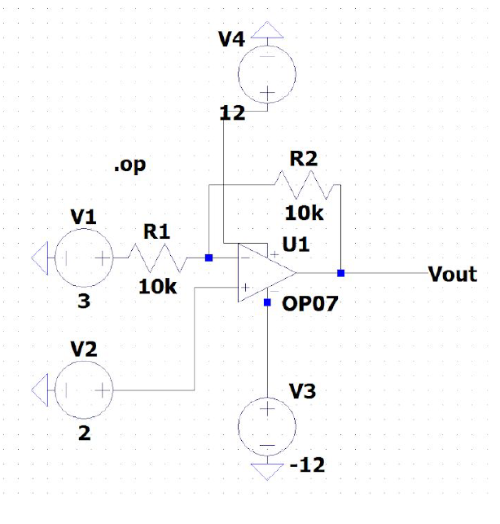

**Observation Table:**

|  |  |  |  |  |
| --- | --- | --- | --- | --- |
| Rf(in KOhms) | V1 | V2 | Vout | V2*(1+Rf/Ri ) - V1(Rf/Ri) in V |
| 10 | 3 | 2 | 0.999997 | 1 |
| 47 | 3 | 2 | -2.69998 | -2.7 |
| 100 | 3 | 2 | -7.99988 | -8 |

**Differential Amplifier**

**Circuit Diagram:**

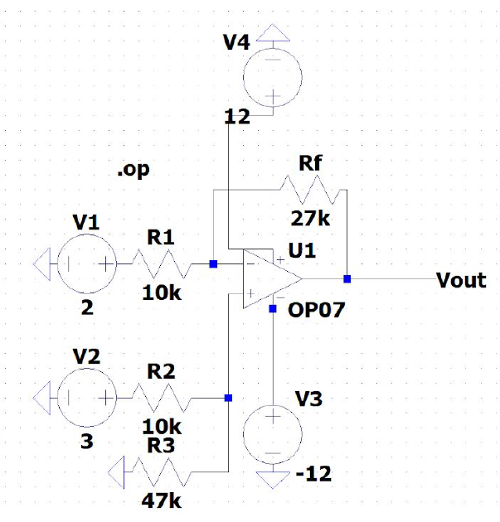

**Observation Table:**

|  |  |  |  |  |
| --- | --- | --- | --- | --- |
| Rf(in KOhms) | V1 | V2 | Vout | V2*(R3/(R2+R3)) - V1(Rf/R1) in V |
| 10 | 3 | 2 | 0.999997 | 1 |
| 47 | 3 | 2 | -2.69998 | -2.7 |
| 100 | 3 | 2 | -7.99988 | -8 |

**Integrator**

1. **Sine Wave**

**Circuit Diagram:**

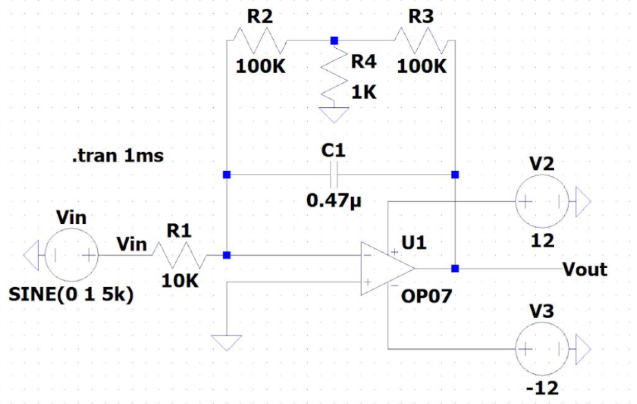

**Input Sine Voltage alone:**

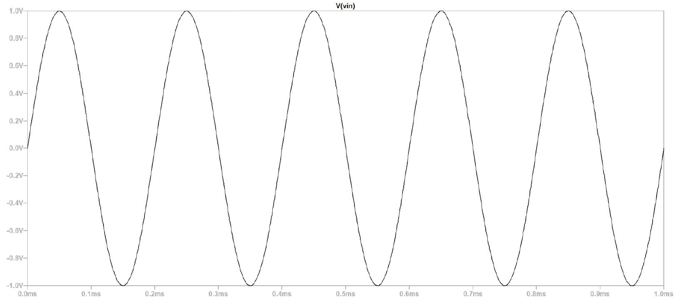

**Output Voltage alone:**

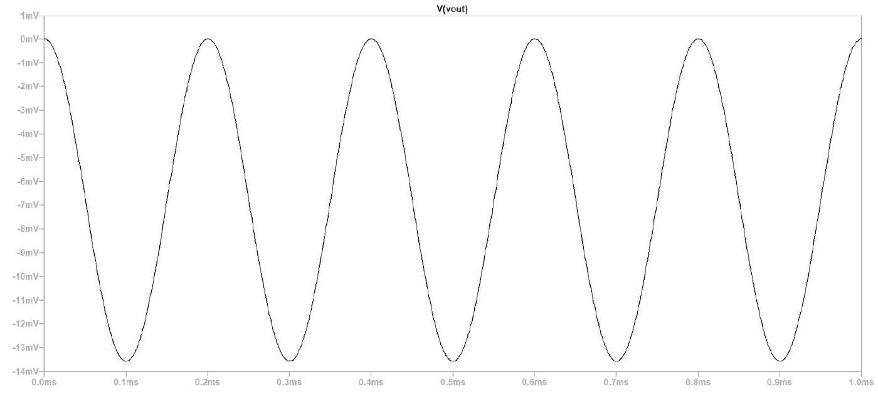

Vout peak minimum voltage = -13.555537V

1. **Square Wave**

**Circuit Diagram:**

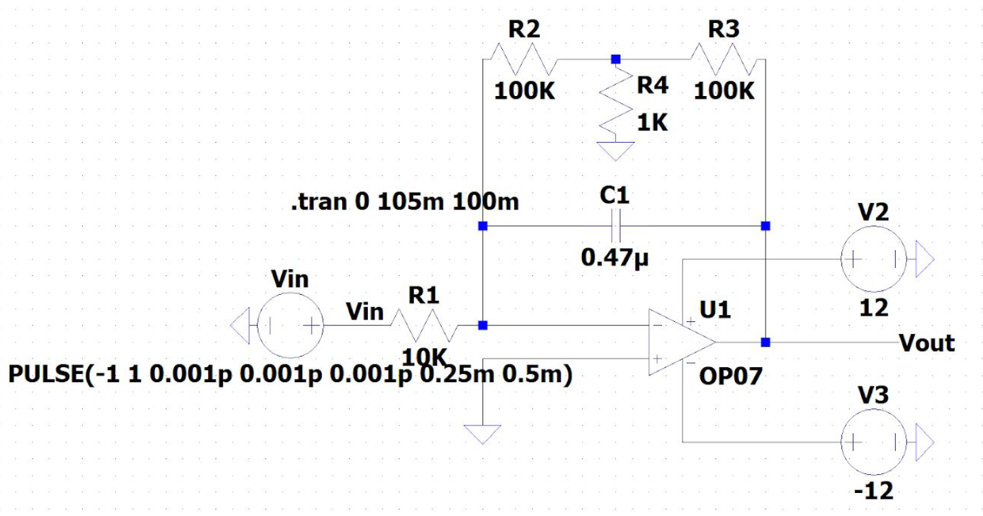

**Square Wave Input alone:**

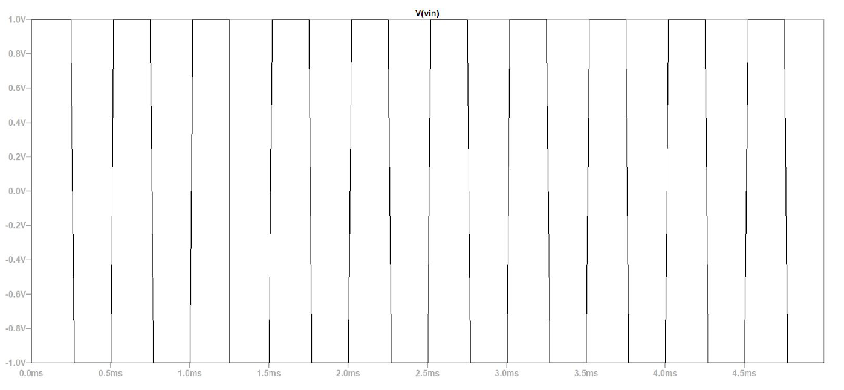

**Square Wave Output alone:**

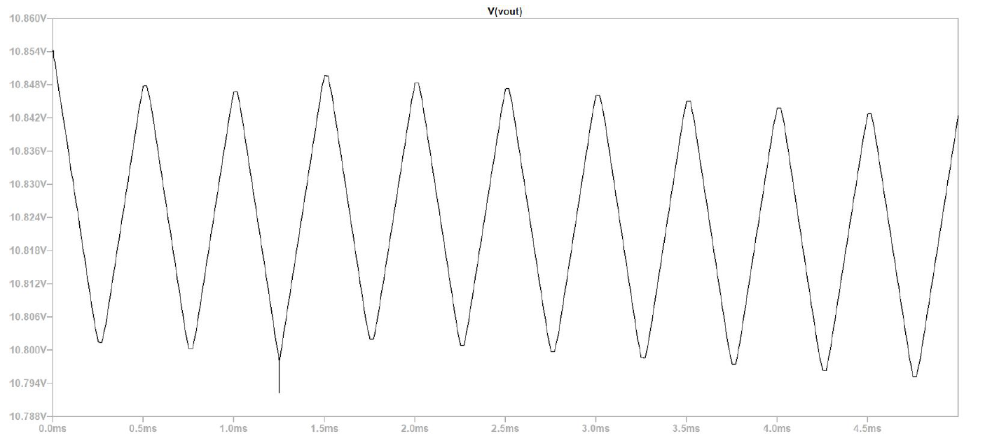

**Observation Table**

|  |  |  |
| --- | --- | --- |
| **Frequency (kHz)** | **Vout**  **Sine Wave in mV** | **Vout**  **Square Wave in mV** |
| 1 | 33.8611 | 119.457 |
| 2 | 16.9333 | 58.511 |
| 3 | 11.2915 | 56.798 |
| 4 | 8.4713 | 46.672 |
| 5 | 6.7778 | 34.134 |
| 6 | 5.6229 | 30.713 |
| 7 | 4.8469 | 28.21 |
| 8 | 4.2439 | 26.286 |
| 9 | 3.7703 | 24.852 |
| 10 | 3.3967 | 23.608 |

**Differentiator**

1. **Square Wave**

**Circuit Diagram:**

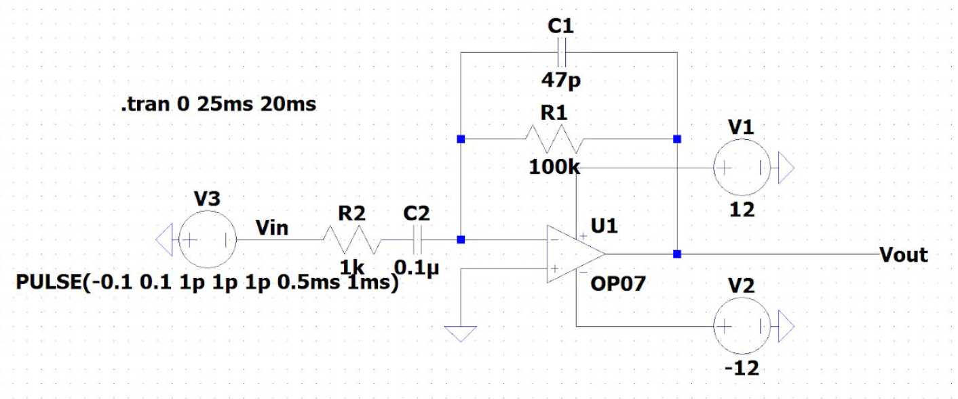

**Square Wave Input:**

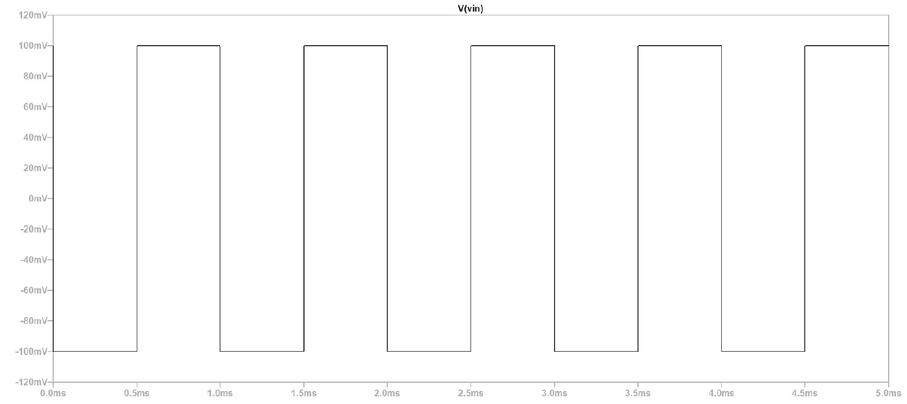

**Output Voltage alone:**

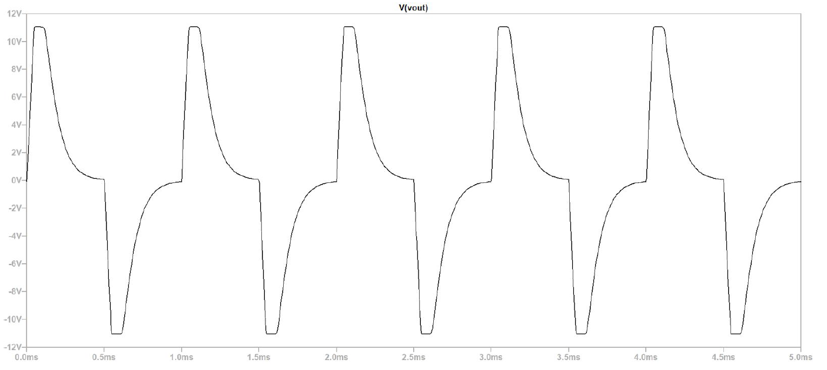

1. **Triangular Wave**

**Circuit Diagram:**

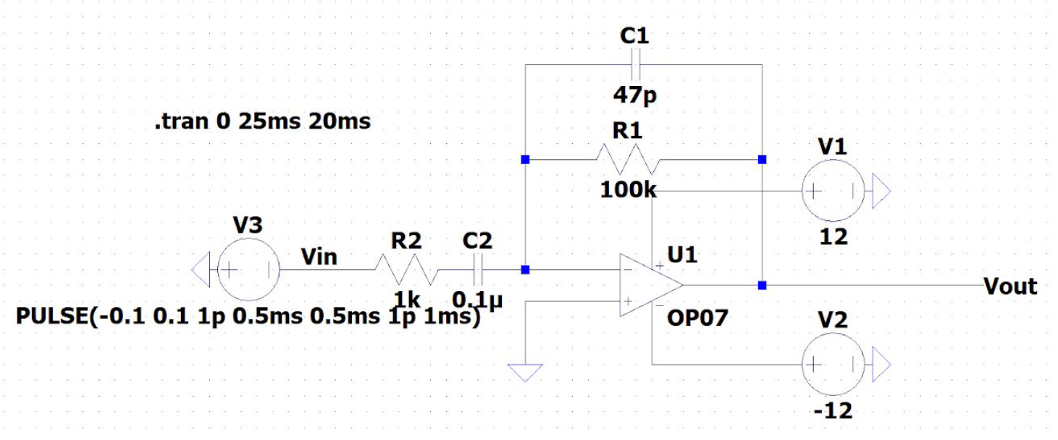

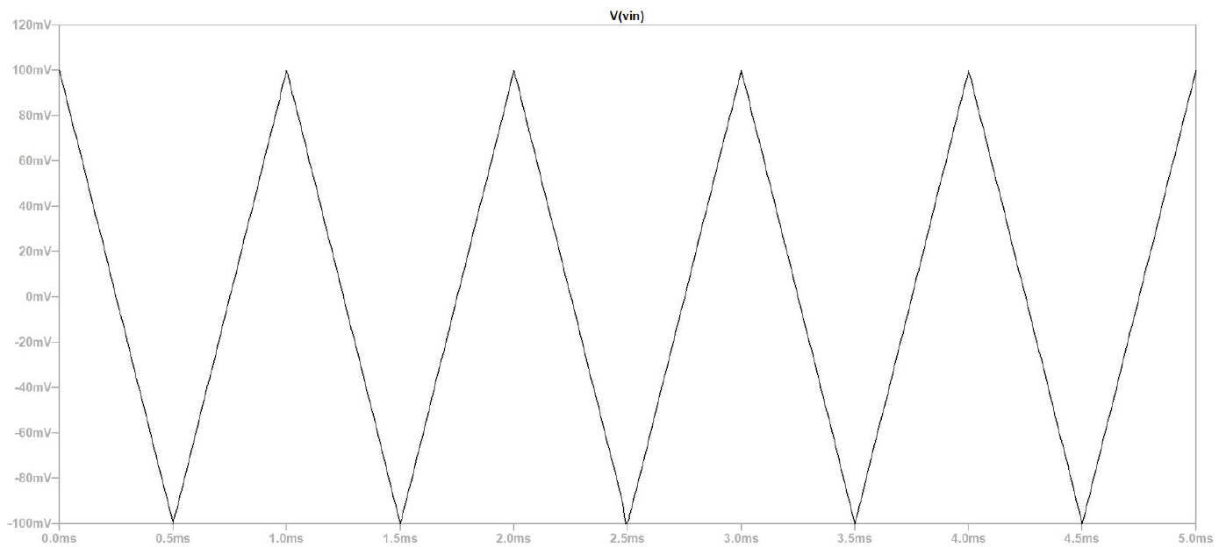

**Triangular Wave output:**

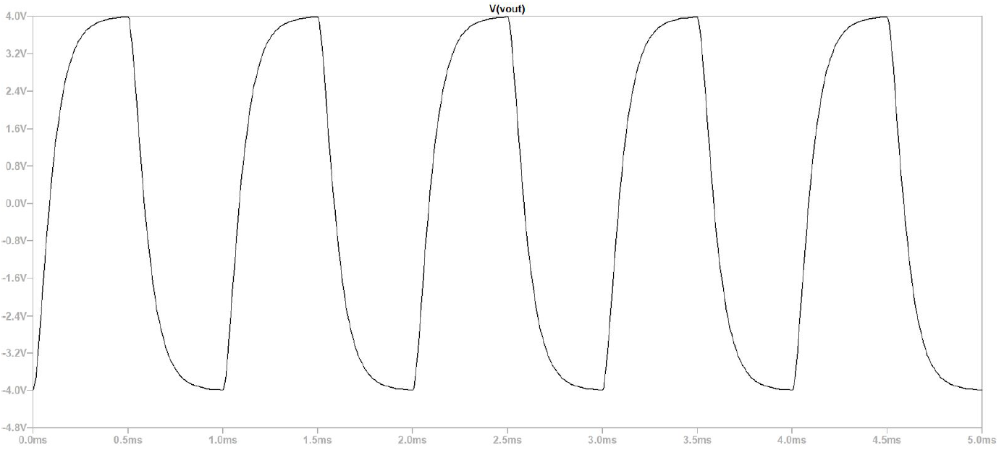

1. **Sine Wave**

**Circuit Diagram:**

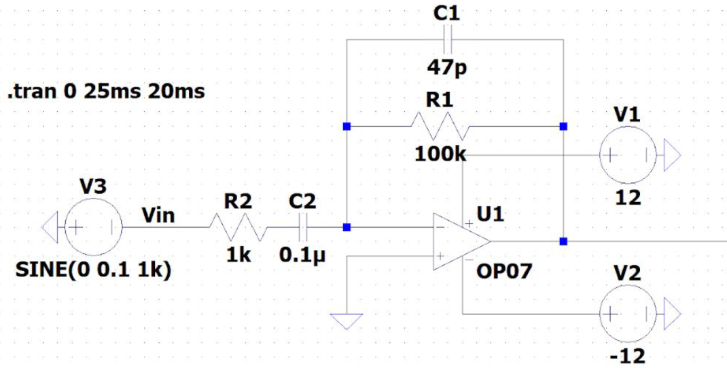

**Sine Wave input:**

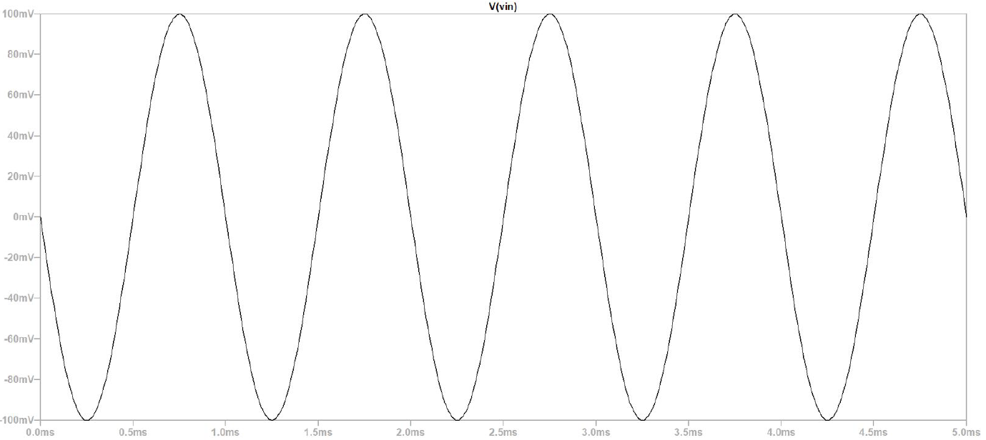

**Sine Wave output:**

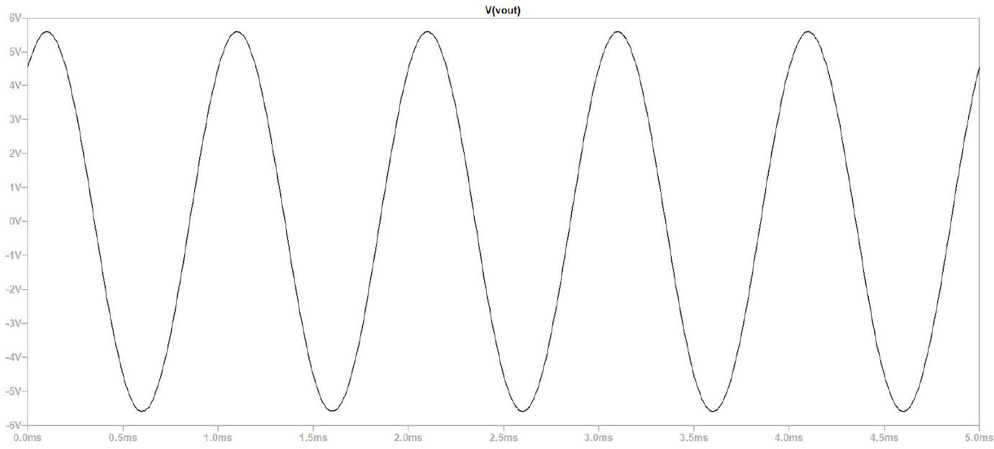

**Observation Table**

|  |  |  |  |
| --- | --- | --- | --- |
| **Frequency (kHz)** | **Vout**  **Sine Wave** | **Vout**  **Square Wave** | **Vout**  **Triangle Wave** |
| 1 | 1.0407V | 11.0665V | 8.0000 |
| 2 | 11.0652V | 11.0594V | 11.0654 |
| 3 | 11.0663V | 11.0659V | 11.0663 |
| 4 | 11.0653V | 11.0654V | 11.0612 |
| 5 | 10.6474V | 11.0659V | 10.6942 |
| 6 | 8.8214V | 10.2210V | 9.3847 |
| 7 | 7.6050V | 8.7989V | 8.3650 |
| 8 | 6.4820V | 7.7660V | 7.5496 |
| 9 | 5.8890V | 6.6889V | 6.8688 |
| 10 | 5.2465V | 6.1675V | 6.3182 |

1. **Conclusion:**
   * Inverting amplifier op-amp circuit amplifies the input voltage and inverts its phase. The gain is given by the formula: Gain = -Rf/Ri. Input signal is connected to the inverting terminal of the op-amp(-)
   * Non inverting amplifier op-amp circuit amplifies the input voltage while also having the output in the same phase. Gain is given by the formula, Gain = (1 + Rf/Ri)
   * The Voltage follower circuit has a voltage gain of 1. This means that the output voltage is equal to input voltage. However this is only true for a small range of input voltages. The output voltage remains constant beyond this range of input amplitudes.
   * Op-Amp adder circuit takes in two input signals and outputs a signal which has an amplitude equal to the sum of the individual amplitudes. This is a useful circuit and can be used to offset AC signals as well by receiving one AC signal and one DC signal to output their sum which is an AC signal offset by the required amount.
   * In superposition op-amp circuits, inputs are provided to both inverting and non-inverting terminals. The output generated is a superposition of each individual signal’s output. Given by the formula: V2*(1+Rf/Ri) - V1(Rf/Ri) in V.
   * Differential amplifiers also use signals connected to both inverting and non inverting terminals of the op-amp to ‘subtract’ a signal from the other. Differential amplifier circuits also make use of the superposition principle and provide and output given by the formula:

V2*(R3/(R2+R3)) - V1(Rf/R1) in V

* + Integrator op-amp circuits like RC integrator circuits return an output that looks similar to the mathematical operation of integration on the input waveform.
  + Differentiator op-amp circuits like RC differentiator circuits return an output that looks similar to the mathematical operation of differentiation on the input signal.

1. **Discussions:**

**General Discussion**

* + The experiments were performed by constructing and simulating the circuits in Lt-spice software.
  + All plots and waveforms were also obtained using the simulation commands pre-built into Lt-spice. The codes for the commands are also mentioned in the circuit diagrams wherever necessary.
  + While performing the simulations it is important to note the biasing voltage for the op-amps as several outcomes depend on it.
  + Rf/Ri value cannot be too high(infinite gain is impossible) because the circuit is limited by the saturation voltage (which itself is dependent on biasing voltage).
  + In some simulations, the circuit acquires steady state only after a short period of time and plotting the simulation before that time would create erroneous results.
  + The values for the components should be checked.
  + The basic Op-amp construction is of a 3-terminal device, with 2-inputs and 1-output . An Operational Amplifier operates from either a dual positive ( +V ) and an corresponding negative ( -V ) supply, or they can operate from a single DC supply voltage. The two main laws associated with the operational amplifier are that it has an infinite input impedance, ( Z = ∞ ) resulting in “No current flowing into either of its two inputs” and zero input offset voltage V1 = V2.Op-amps can be connected into two basic configurations, Inverting and Non-inverting.

**Inverting and Non-Inverting**

* + By adding more input resistors to either the inverting or non-inverting inputs Voltage Adders or Summers can be made. Voltage follower op-amps can be added to the inputs of Differential amplifiers to produce high impedance Instrumentation amplifiers. The Differential Amplifier produces an output that is proportional to the difference between the two input voltages
  + In its simplest form the op-amp inverting amplifier only requires the use of two additional resistors to be included within the electronic circuit design process. This makes the circuit very simple and easy to implement.
  + One of the main features of the inverting amplifier circuit is the overall gain that it produces. It depends on external resistances only. Thus, it can be easily controlled by varying the external parameters. Few properties of Op-Amp make it an ideal amplifier, its open loop gain and input impedance is very high and output impedance and offset voltage is very low and bandwidth is infinite.
  + Inverting amplifiers exhibit excellent linear characteristics which make them ideal as DC amplifiers. Moreover, they are often used to convert input current to the output voltage in the form of Trans-resistance or Transimpedance Amplifiers. Further, these can also be used in audio mixers when used in the form of Summing Amplifiers.
  + A non-inverting amplifier is an op-amp circuit configuration which produces an amplified output signal. This output signal of non-inverting op amp is in-phase with the input signal applied. In other words, a non-inverting amplifier behaves like a voltage follower circuit.

**Integrator and Differentiator**

* + An op-amp integrator circuit performs the mathematical operation of integration on the input waveform, therefore the output voltage is proportional to the integral of input voltage over time.
  + In the integrator circuit of an op-amp with sine wave as input waveform, the output depends on frequency. Therefore it acts as a low pass filter because the output is very small when frequency is increased. Also, the output waveform is always negative and there is a phase difference of 90 deg.
  + When a square waveform is given as input to an integrator op-amp circuit, a triangular waveform is generated as output. When the square waveform is in positive half cycle, the output voltage decreases whereas when the square waveform is in negative half cycle, the output voltage increases.
  + The op-amp differentiator circuit performs the mathematical operation of differentiation on the input waveform, therefore the output voltage is proportional to the rate of change of input voltage with respect to time.
  + In the differentiator circuit with sine wave as input waveform, the circuit acts as a high pass filter as the amplitude decreases with frequency. The amplitude also changes with the product of R and C. Also, a phase difference of 90 deg is observed between input and output. In the differentiator circuit with square wave as input waveform, in Vlabs there is a bug.it is hardcoded with frequency of 2000 Hz. For other frequencies, the output remains unchanged.
  + As observed from the experiment, the integrator and differentiator circuits using Opamp give us the mathematical integral and differentiation waveform for any applied input signal.
  + The output obtained is the integral or differentiation of the input, but there is a proportionality value as well which determines the amplitude of the output waveform. This value depends on the value of resistance and capacitance used in the circuit, thus can be adjusted during circuit construction accordingly.
  + A 180 degree phase shift can be observed between the input and output waveforms.
  + Applications of Integrator and Differentiator:

The integrator circuit can be used in analog computers, analog-to-digital converters, wave-shaping circuits, charge amplifiers, etc. Opamp differentiator circuits can be operated on triangular and rectangular signals and can be used to process them. Differentiators can also be used in wave shaping circuits, in detecting high frequency components, and other such varied applications.

* + The **Integrator Amplifier** produces an output that is the mathematical operation of integration. The **Differentiator Amplifier** produces an output that is the mathematical operation of differentiation. Both the Integrator and Differentiator Amplifiers have a resistor and capacitor connected across the op-amp and are affected by its RC time constant.
  + In practice, the output voltage of a **voltage follower** will not be exactly equal to the input voltage applied and there will be a slight difference. This difference is due to the high internal voltage gain of the op-amp. The high input impedance and low output impedance of the non-inverting amplifier makes the circuit ideal for impedance buffering applications.